Personality

What is personality?
- Refers to a person’s general style of interacting with the world, especially other people. It is a trait that is less likely to change in the short term, and may remain constant throughout your lifetime.
  - People have naïve beliefs they can easily evaluate personality

MBTI (Myers-Briggs Type Indicator)
- Widely used personality assessment tool, classifies individuals on 4 axes:
  - Extroverted v. Introverted: extroverts are more outgoing and assertive while introverts are quiet and shy
  - Sensing or Intuitive: sensing individuals are practical, enjoy order and are detail oriented. Intuitive people are more “big picture” oriented and rely on “gut” feelings
  - Thinking or Feeling: this dimension is important in decision making as thinkers use reason and logic while feelers use emotions to make decisions
  - Judging or Perceiving: judgers are control-oriented and enjoy structure and order. Perceivers are more flexible and spontaneous
- These 8 sub-characteristics combine to give 16 “types”

Problems with MBTI
- Can be faked in job application survey
- Subjectivity
- Is it based on scientific findings? Based on Carl Jung’s personal opinion, his gut feeling.
- MBTI types do not predict organisational outcomes.

The Five Factor Model – Big 5
- Developed using scientific method
  - Generated hundreds of personality items
  - Participants rated their personality using these 900 items
  - Ran confirmatory factor analysis to generate personality dimensions
  - Found 5 main dimensions
  - Validated these in many cultures
- Does not categorise personality, instead shows 5 factors which can effectively summarise your personality. These are:
  - Extraversion – ways in which you interact with others
    - Explains +0.24 of income variance
  - Agreeableness – degree to which you are willing to defer to others. Agreeable = co-operative and trusting
  - Conscientiousness – measure of personality consistency and reliability. Very important in workplace
    - Explains +0.34 proportion of income variance
  - Emotional stability (or neuroticism) – degree to which you can withstand stress
    - Neuroticism explains -0.32 proportion of income variance
  - Openness – range of interest in novelty (creative, curious etc)

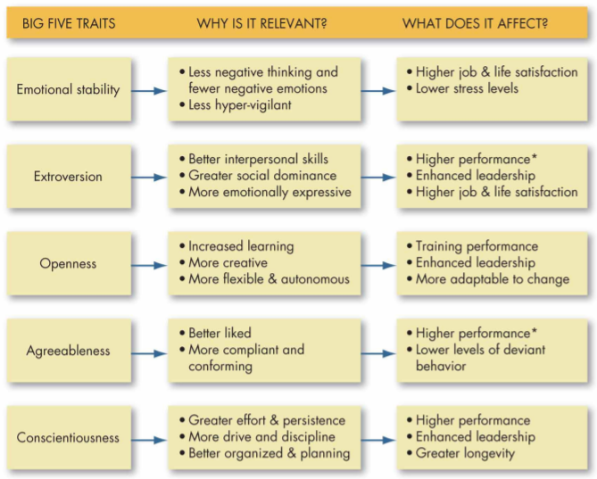

What determines personality?
- Heredity is most dominant factor: genetics more important than parenting. Twins separated at birth had high correlation between their personalities
  - Explains 20% of personality on its own
- Environmental factors: parents, friends, physical environments etc explain 80% combined
- Aging – will openness to experience will go down? Not true, basic personality is constant

Should companies use personality tests?
- 9% of companies use MBTI
- Birkeland et al. study faking on personality tests: applicants scored significantly higher on extraversion, emotional stability, conscientiousness, and openness.
  - Could be conscious, could be unconscious i.e. selectively recalling favourable situations
- Implication is that job candidates are motivated to fake their personality, so companies shouldn’t use them

Readings

Birkeland et al (2006) – Faking on Personality Measures
- to which job applicants fake their responses on personality tests.
  - Predicted higher mean scores as job applicants wish to present themselves in favourable, socially desirable manner.
  - Secondly, predicted larger effect sizes for conscientiousness and emotional stability because these are the dimensions perceived by applicants as most important.
- Moderating variables of job types were examined e.g. sales jobs had larger effects for extraversion, managerial jobs larger effect of conscientiousness
  - Big five model of personality (Digman, 1990). Extent of faking appears greater on direct Big Five measures than indirect Big Five measures.
- Viswesvaran and Ones (1999) had already showed participants are able to distort their responses on personality measures when instructed to do so.
  - Furnham (1990) had shown that participants were able to tailor their “fake-good” responses based on their perception of the personality traits of employees in the target job.

Implications and further research
- More research needed on the magnitude and impact of such faking. Faking may change the rank order of individual scores thus hiring decisions (Hough, 1998).
  - Score corrections based on social desirability scales have no evidence that they account for individual faking (Piedmont et al, 2000)
- Personality test develops could develop less transparent test items so it is less obvious whe faking an item will increase an applicant’s attractiveness to the organisation (Jackson et al, 2000).
  - Alternatively, contextualising personality items by making it transparently related to work can increase the validity of personality measures (Bing et al, 2004).
  - Could also just warn applicants that faking can be identified, which would decrease the likelihood of faking (Dwight and Donovan, 2003)

Barrick (1991) – The Big Five Personality dimensions and job performance
- Investigates the relationships between the Big 5 personality dimensions and three job performance criteria (job proficiency, training proficiency and personnel data).
  - Conscientiousness showed consistent relations for all criteria across all occupation groups.
  - Other 4 had correlations which varied across job criteria and occupational group.
    - Extraversion was a valid predictor for occupations involving social interaction, managers, and sales, across all criteria
    - Openness and extraversion were valid predictors of the training proficiency criterion.

